4. Problem Solving
This chapter sets out how the problem defined in Chapter 3 was actually solved: the research design adopted for each objective, the hypotheses tested, how the sample was arrived at and why it was considered adequate, the instrument used to collect the underlying data, the descriptive picture of the sample before modelling began, the conceptual framework linking the four objectives together, and the steps taken to verify and validate the results before they were reported in Chapter 5.
4.1 Research Design
This study followed a quantitative, ex post facto research design, built entirely on secondary panel data rather than on data collected through experiment or survey. No variable was manipulated; the financial condition of each company had already occurred by the time it entered the dataset, and the analysis worked backwards from recorded outcomes to their associated firm-level and macroeconomic conditions. A single firm-year panel, covering financial years 2014 to 2025 for 3,082 listed Indian manufacturing companies, was constructed to serve all four objectives, but the design applied to that panel changed according to the question being asked of it.
For Objective 1, a cross-sectional association design was used: financial ratios and firm characteristics were related to a contemporaneous distress label, that is, to distress occurring in the same year as the ratios themselves. For Objective 2, this was replaced by a predictive, forecasting design, in which a firm-year's ratios were used to predict distress in the following year, and the sample was split chronologically into a training period and a later, held-out test period so that the models could be evaluated on years they had not been trained on. Objective 3 adopted a post-hoc explanatory design, applied to the single best-performing model identified under Objective 2 rather than to a newly estimated one. Objective 4 used a comparative design, re-examining the same model's performance within subgroups of the data, defined by manufacturing sector, regulatory regime, and the COVID-19 period, to assess how far its performance generalised beyond the full pooled sample.
4.2 Hypothesis
Four hypotheses were formulated, one corresponding to each objective, and each was tested using the design just described.
- H1: Firm-specific financial ratios and firm characteristics are significantly associated with financial distress among Indian manufacturing companies. This was tested through univariate Mann-Whitney U comparisons across ten firm-level variables and a multivariate logistic regression with industry and year fixed effects across nine of those variables (Objective 1). All ten variables differed significantly between distressed and non-distressed firm-years in the univariate comparison; once industry and year effects were controlled for, eight of the nine variables retained significance, with the current ratio losing significance (p = 0.840), indicating that its univariate association had reflected industry and year variation rather than a standalone effect. This provided substantial support for H1.
- H2: Machine learning models achieve significantly higher classification accuracy than the traditional Altman Z″-score and Springate S-score models. This was tested by comparing AUC-ROC scores for three machine learning classifiers against both benchmark scores on an identical, chronologically held-out test set (Objective 2). XGBoost achieved the highest AUC (0.889), ahead of both benchmarks, supporting H2.
- H3: Different categories of financial indicators contribute unequally to the model's predictions. This was tested using SHAP-based feature and category-level importance applied to the winning model from Objective 2 (Objective 3). Profitability and debt-service indicators were found to dominate the model's decisions, supporting H3.
- H4: The predictive performance and importance of indicators differ significantly across manufacturing sub-sectors and across regulatory and economic periods. This was tested through subgroup AUC comparisons across ten Manufacturing Sector Groups, the pre-/post-IBC regime split, and the COVID-19 period (Objective 4). Meaningful differences were found across sectors, but the pre-/post-IBC comparison could not be completed within the chronological design adopted for this study, so H4 was only partially supported.
The full statistical detail behind each of these verdicts, coefficients, p-values, and AUC tables, is reported in Chapter 5; this section records only how each hypothesis was tested and the direction of the finding.
4.3 Sample Size Calculation
Rather than being set in advance through a power calculation, as would be typical of a primary survey-based study, the sample size in this study was the outcome of a sequential filtering process applied to the full population of companies available in the CMIE ProwessIQ database. An initial extraction of 5,833 listed Indian companies, across all industry classifications, formed the starting population. Thirteen industry groups corresponding to financial-services activities, which fall outside the manufacturing scope of this study, were then excluded, removing 1,026 companies and leaving 4,807 companies. A further screening step removed any company for which more than 30 per cent of the required financial data was missing across the sample window, a threshold conventionally applied in panel-based accounting and finance research to prevent models from learning from heavily imputed or sparse records. This step removed 1,725 additional companies, leaving a final sample of 3,082 manufacturing companies, reshaped into a firm-year panel of 36,984 observations.
Although no formal power analysis was carried out, since the study did not rely on random sampling from a hypothetical population but on the near-complete population of qualifying listed companies, the adequacy of this sample size was checked against the conventional events-per-variable (EPV) rule used for logistic regression, which recommends at least ten outcome events for every predictor variable included in the model. With an overall distress rate of 18.73 per cent across 36,984 firm-year observations, the panel contained approximately 6,928 distressed firm-year events, against nine firm-level predictors in the main specification, an EPV several hundred times larger than the conventional minimum. For Objective 2's chronological train-test design, the training set (21,053 observations, FY2014 to FY2021) and test set (8,175 observations, FY2022 to FY2024) were each individually large enough to support stable coefficient estimation and a reliable AUC comparison across five competing models.
4.4 Data Collection Instrument
This study did not involve a questionnaire or any other primary data-collection instrument administered to respondents, since the research questions concerned the financial condition of companies rather than the opinions, perceptions, or behaviour of individuals. In place of a questionnaire, a structured secondary-data extraction template served the equivalent function of defining exactly what was to be collected and from where. Firm-level data were extracted from the CMIE ProwessIQ database using a fixed template of financial-statement line items, namely total income, operating income, total assets, current assets, current liabilities, net worth, interest expense, profit after tax, profit before interest and tax, and net cash flow from operating activities, recorded annually for each company across financial years 2014 to 2025. Four macroeconomic series, GDP growth and WPI inflation from the Reserve Bank of India, the Economic Policy Uncertainty Index from policyuncertainty.com, and the industry Weighted Average Lending Rate, were extracted separately and merged onto the firm-level panel by financial year. Together, this extraction template defined the full set of variables used to construct the ratios, the distress label, and the macroeconomic controls employed throughout the four objectives.
4.5 Descriptive Statistics
Before any model was estimated, the panel was examined descriptively to establish how common financial distress was and how it had moved over the sample period. Across all 36,984 firm-year observations, 18.73 per cent were coded as distressed under the composite label. This overall rate concealed a distinct pattern over time: the distress rate held broadly steady, between approximately 15.6 and 19.5 per cent, across most of the sample period, before rising sharply during the COVID-19 years, from around 17.5 per cent in FY2019 to 22.6 per cent in FY2020 and a peak of 23.8 per cent in FY2021, and then falling back to 15.6 per cent by FY2025, the lowest rate recorded in the panel.
Distressed and non-distressed firm-years were then compared directly across the ten financial ratios and firm characteristics used in Objective 1, using the Mann-Whitney U test in preference to a t-test, since financial ratios are typically skewed rather than normally distributed. All ten variables differed significantly between the two groups at the 5 per cent level. The clearest separation was found in the interest coverage ratio, which averaged 38.83 among non-distressed firm-years against -0.59 among distressed firm-years, followed by net worth to total assets (0.50 against 0.03) and working capital to total assets (0.21 against -0.13). Profitability measures followed the same pattern, with both EBIT to total assets and return on assets negative, on average, among distressed firms and positive among non-distressed firms. The full table of group means and test statistics is reported as Table 5.1 in Chapter 5.
4.6 Conceptual Model / Framework
The four objectives were not run as independent, unconnected exercises; each fed into the next, forming a single pipeline running from raw data to an interpretable, tested early-warning model. Figure 4.1 sets out this pipeline. The firm-year panel and the four macroeconomic series were first combined and used to engineer the ratios, firm characteristics, and distress label common to all four objectives. From there, Objective 2 constructed a one-year-ahead prediction problem and a chronological train-test split, on which three machine learning classifiers and two formula-based traditional benchmarks were evaluated side by side. The best-performing model to emerge from this comparison was then carried forward twice more: once into Objective 3, where SHAP was used to explain its predictions, and once into Objective 4, where its performance was tested for stability across sectors, regulatory regimes, and the COVID-19 period. Objective 1 sits slightly apart from this left-to-right flow, since it worked with the full contemporaneous panel rather than the one-year-ahead prediction subset, but it supplied the same underlying set of ratios and characteristics that the predictive and explanatory stages later relied on.
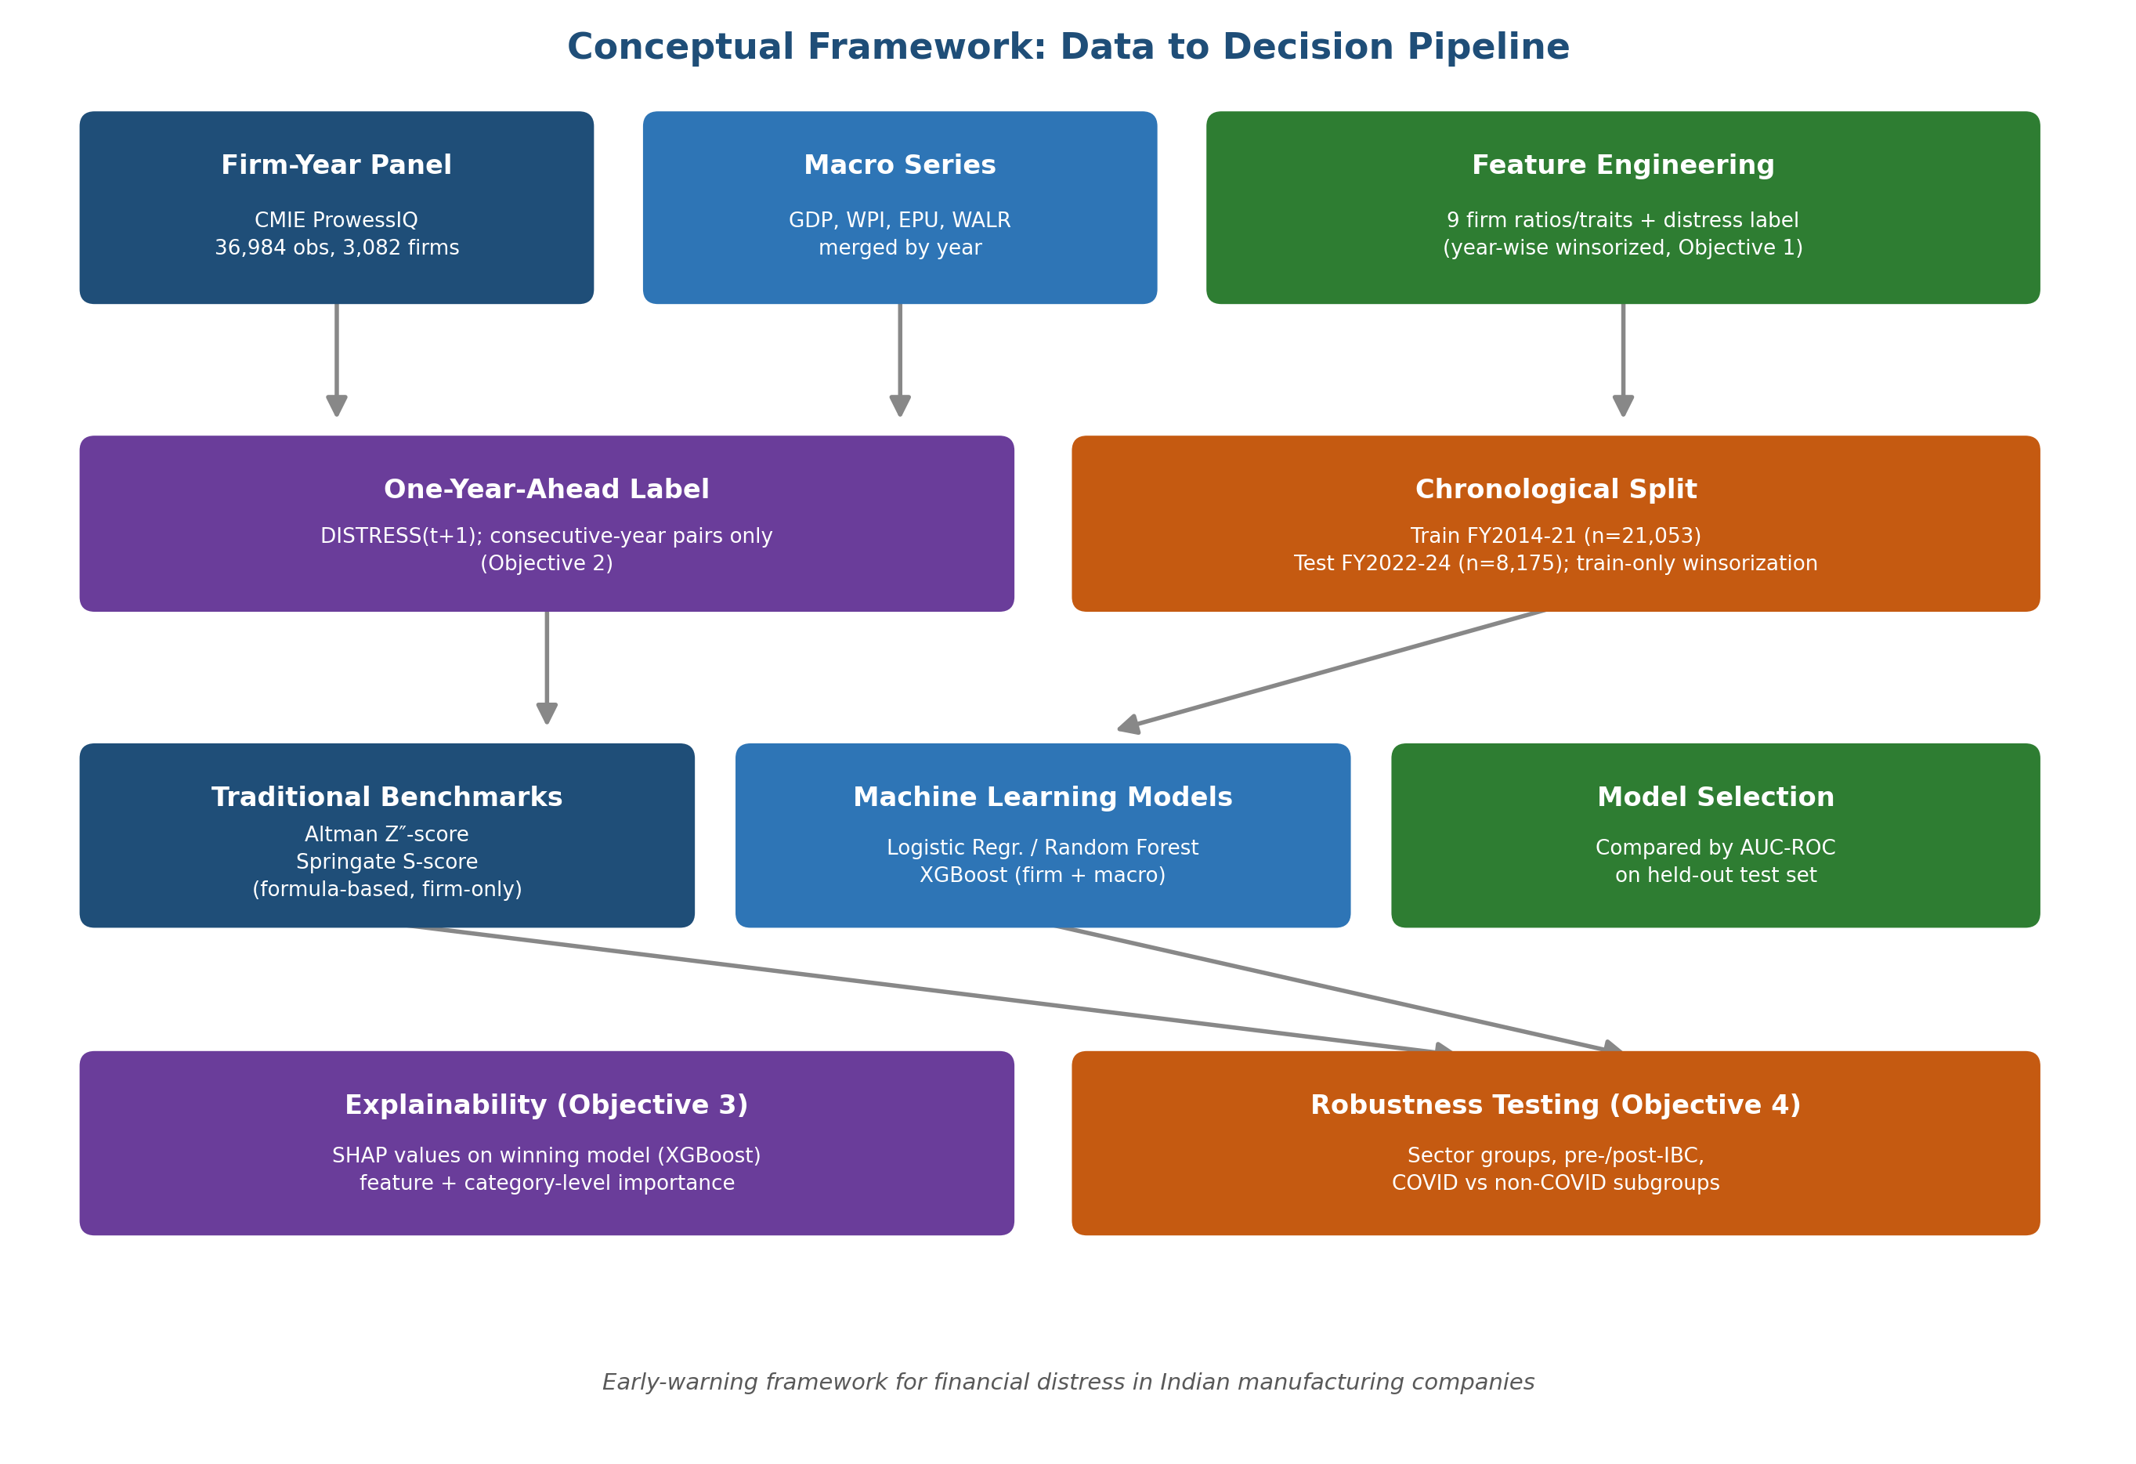
Figure 4.1: Conceptual framework linking the four objectives, from raw data to a tested early-warning model.
4.7 Verification and Validation
Several safeguards were built into the analysis to verify that the results could be trusted and to validate that they would hold up outside the exact sample on which the models were built. The most fundamental of these was the use of a chronological, rather than random, train-test split for every predictive analysis: models were trained only on FY2014 to FY2021 and evaluated only on FY2022 to FY2024, so that no model was ever evaluated on a year that had, directly or indirectly, informed its training. Winsorization bounds for Objectives 2 to 4 were derived from the training years alone and then applied unchanged to the test years, preventing information from the test period from leaking backwards into the data-cleaning step, a leakage route that is easy to overlook but would have inflated the reported accuracy had it been left unaddressed.
Class imbalance, with distress accounting for under one-fifth of observations, was addressed directly within each model rather than by altering the underlying data: Logistic Regression and Random Forest were fitted with balanced class weights, and XGBoost was fitted with a positive-class scaling factor derived from the training set's own class ratio. A fixed random seed was used throughout, so that the reported results could be reproduced exactly by re-running the same notebooks. Validation of the machine learning results against an external point of reference was provided by the two traditional benchmark scores, the Altman Z″-score and the Springate S-score, computed from their published formulas rather than fitted to this sample, and evaluated on the identical held-out test set as the machine learning models; the machine learning models' outperformance of both independently-sourced benchmarks served as one check that the reported accuracy was not simply an artefact of this particular dataset.
Generalisability was validated separately under Objective 4, by re-testing the selected model's performance within ten Manufacturing Sector Groups, across the pre-/post-IBC regulatory split, and across COVID versus non-COVID periods using a period-specific 70/30 design where the chronological split could not otherwise isolate the pandemic years. Where this validation could not be completed as intended, specifically the pre-/post-IBC comparison, for which the chronological test window fell entirely within the post-IBC period, this limitation was reported explicitly rather than concealed, consistent with treating validation as a genuine check on the model rather than a formality to be satisfied.

